1. Determine the biomass produced.
- Find a yardstick or metal frame of known dimensions.
- In several areas of your field, clip the plants at ground level within the known area.
- Dry the samples in an oven at about 140°F for 24 to 48 hours until they are crunchy dry
- Calculate: 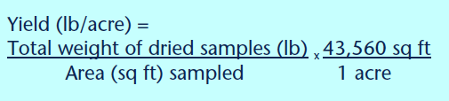
Example: You have sampled two 2x2 ft regions of your field. How much biomass per acre do you have?
Area sampled: 2x2 = 4 ft² * 2 = (8 ft² )
2ft
2ft

The2 dried samples together weigh 1.2 lbs.
1.2 lbs * 43,560 sq ft = 6534
8 ft² 1 acre
ANSWER: 6,534 LB ACRE (dry biomass yield)

2. Determine the nutrient levels in that biomass.
- Use tissue tests or estimate %N in cover crop
Tissue Tests: Send to NCDA for Plant Tissue Analysis, for an exact %N. Pick up mailing envelopes for plant tissue samples at any county Cooperative Extension office.
http://www.ncagr.gov/agronomi/uyrplant.htm

Estimate: Use approximate N% of known cover crops. (See “How much N can a legume fix?”)
- Multiply the dry biomass yield times the percentage of nitrogen

Example: If your hairy vetch cover crop in the last example has 4% N at kill, how much N are you applying to your field?
(6534 lbs/acre)(.04) = 261
ANSWER: 261 lbs of N (legume biomass N)

3. Predict how quickly the biomass will decompose, releasing nutrients for cash crops.
- Estimate how much N is made available to your crop, multiply legume biomass nitrogen:
0.50 if the cover crop residue will be incorporated
0.40 if the residue will be left on the soil surface
Example: If your hairy vetch is incorporated in the soil in early may in a normal spring, how much N will be available to your crop?
(261 lbs of N)(.50) = 130.5
ANSWER: 130.5 lbs of N per acre (available N to crop)

